# Exercise: Computer Systems and Software - Git

Problems for exercises and homework for the ["Software Technologies" course @ Software University.](https://softuni.bg/trainings/4086/software-technologies-may-2023)

## What is it and why you need it

**Git** is a distributed **version control system** that allows developers to track changes in their code and collaborate with others. It is platform-agnostic and can be used on various operating systems, including Windows, macOS, and Linux. It is a useful tool for enhancing testers' efficiency and collaboration by providing version control and traceability for test artifacts, facilitating teamwork and streamlining the testing process.

**Git for Windows**, is a specific distribution of Git that is tailored to work seamlessly on the Windows operating system.

## How to install

**1.** Navigate to <https://gitforwindows.org/> and click **Download**

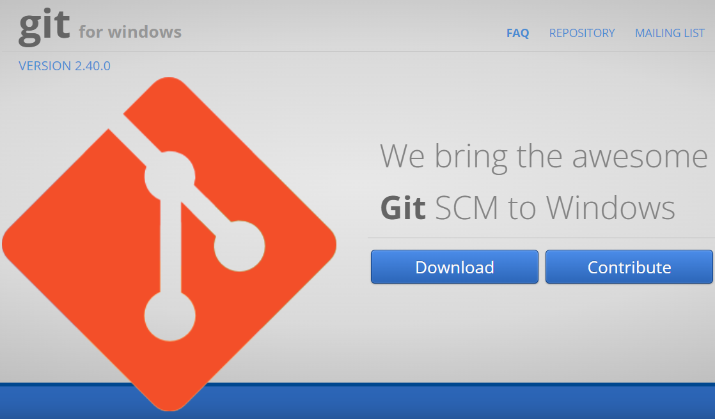

**2.** The .exe file will be downloaded to your browser.



**If you need the 32-bit version, go to:**

<https://github.com/git-for-windows/git/releases/download/v2.40.0.windows.1/MinGit-2.40.0-32-bit.zip>

**3.** Double click on .exe file to initiate the installation process. When prompted by Windows, give permission to make changes. You will get a General Public License Information screen. Click "Next" button.

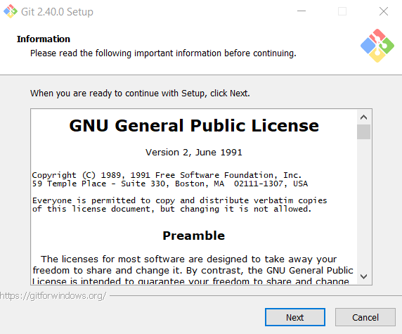

**4**. **Choose the desired path** where you want to install Git.

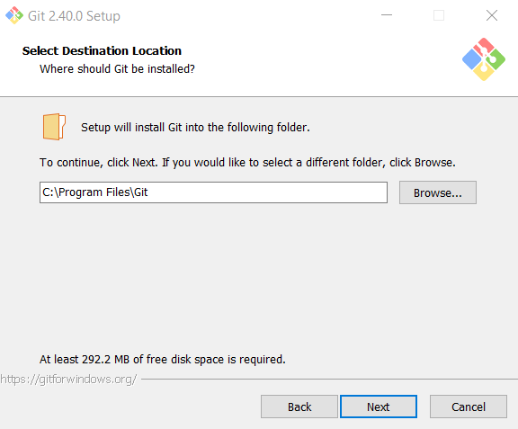

**5.** Leave the Select Components screen as it is. **Don't change anything**. Click **Next.**

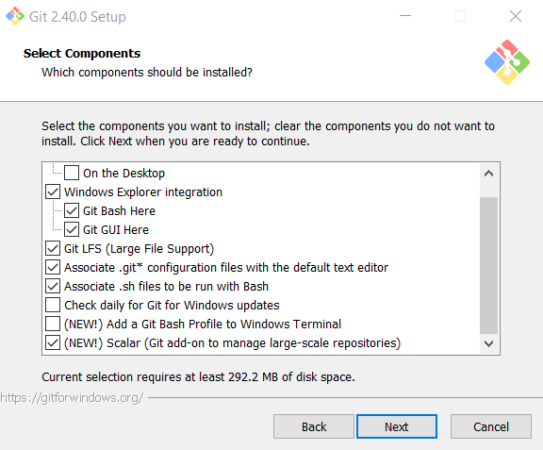

**6. Select Start Menu Folder** or not to create Start Menu Folder

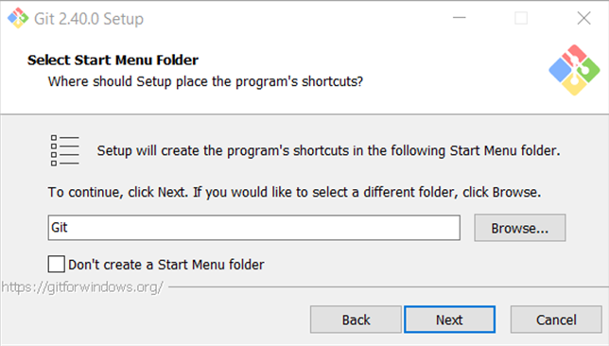

**7. Choose Notepad or Notepad++** for the default editor.

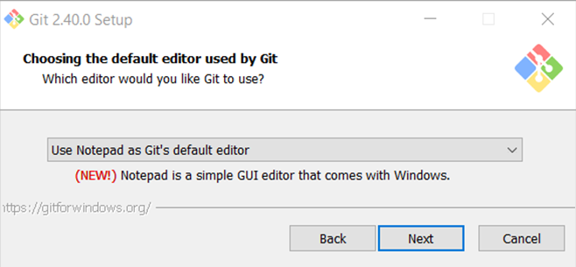

**8. Let Git decide** for the initial branch.

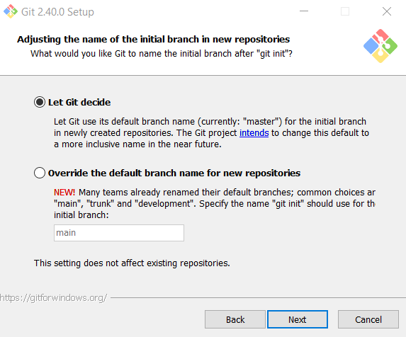

**9. Choose the second** **option** to be able to use Git from Command Prompt.

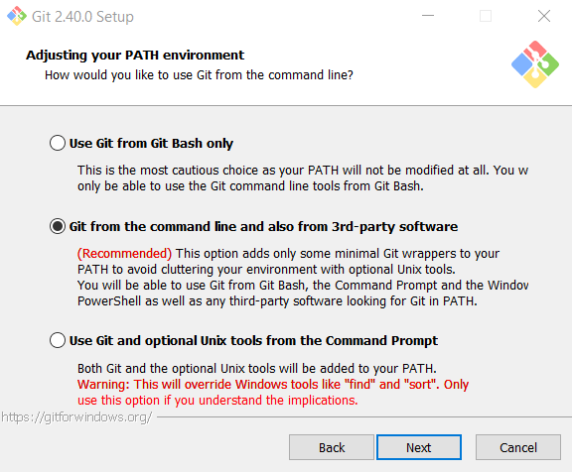

**10. Leave this option as it is.**

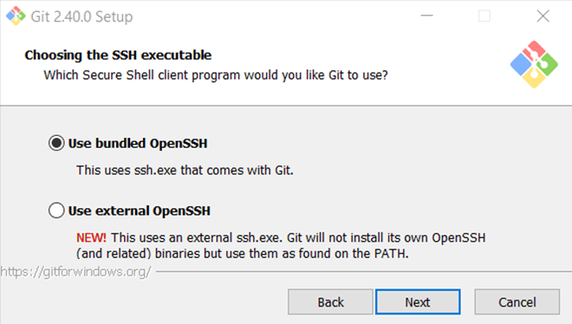

**11. Leave this option as it is** as well.

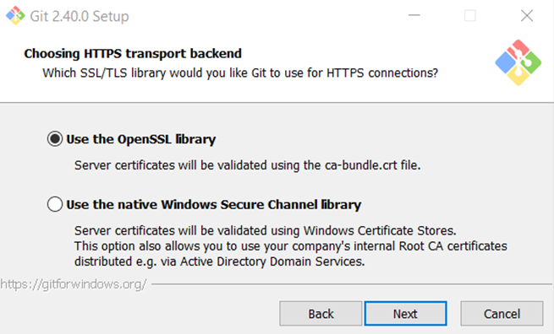

**12.** This one **stays the same** as well.

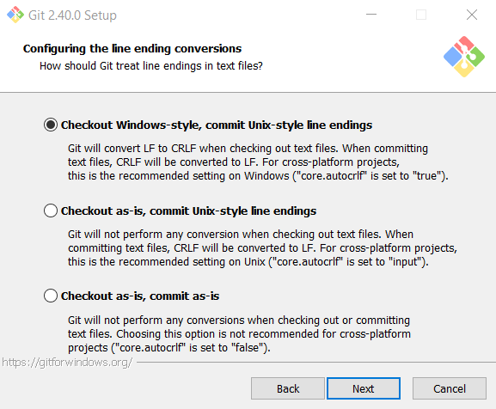

**13.** Select **Use Windows' default console window** option.

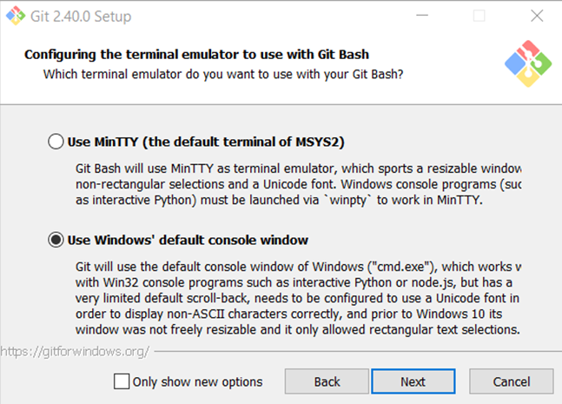

**14.** Default behavior – **Default.**

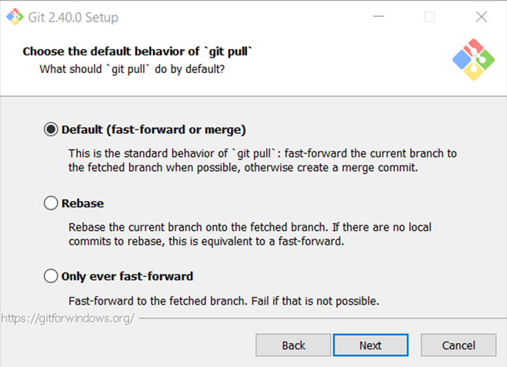

**15. Git Credential Manager**

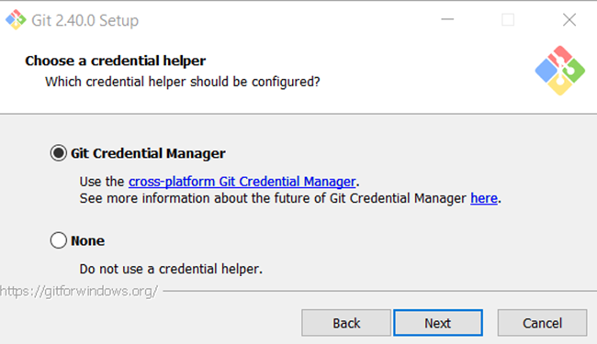

**16. Enable file system caching**

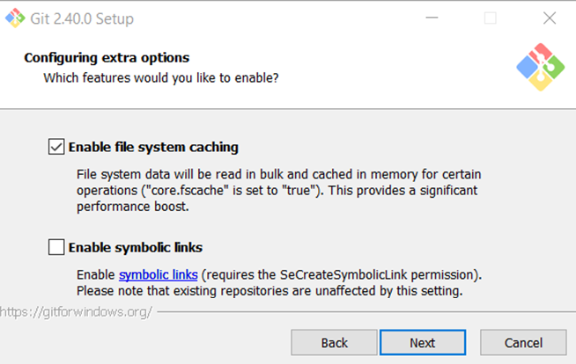

**17.** Leave the **experimental options unchecked. Click Install.**

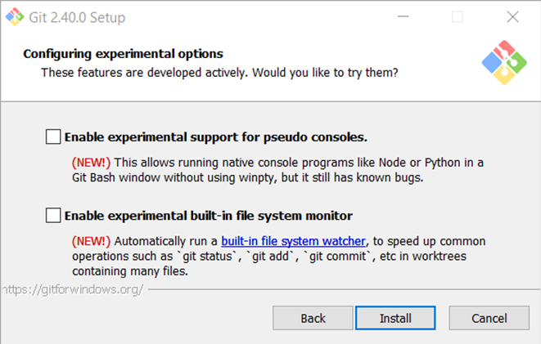

**18.** Installing…

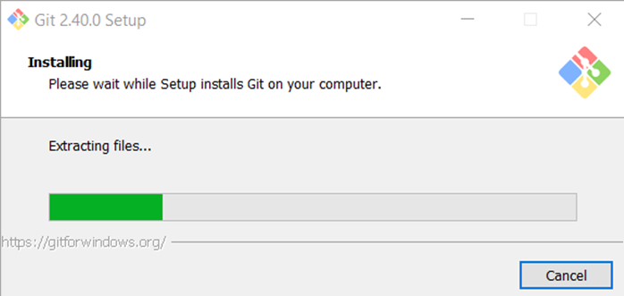

**19.** Complete the setup by pressing **Finish.**

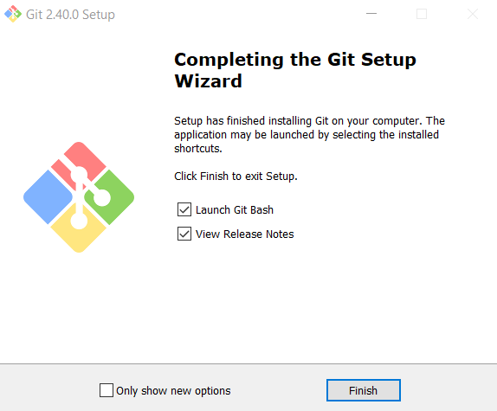

## Check Git version

To **check the Git version**, run the following command:

* from the command prompt **git version**
* from git bash **$ git –version**

## Turn on/off Copy/Paste options

Keep in mind that by default copy/paste options in git bash are disabled, so in order do use them, you have to right-click on the title bar and choose properties.

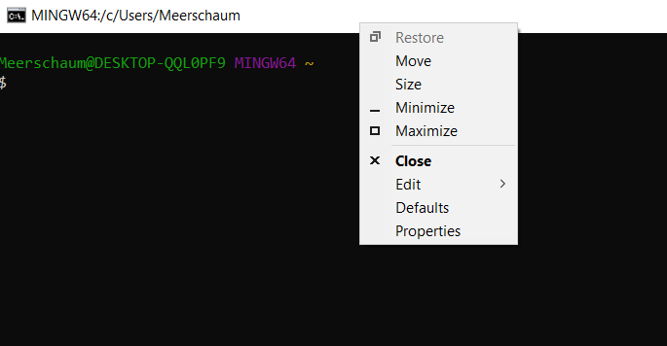

A new window will pop up, where you should make sure that the following option is checked:

**Use Ctrl+Shift+C/V as Copy/Paste**

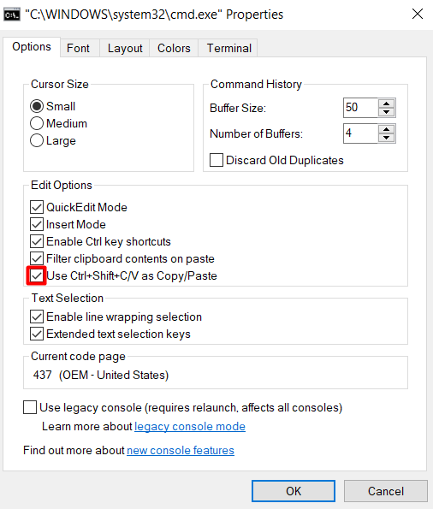

## Clone GitHub repository

For the following exercise you can use **command prompt** or **git bash**. The syntax is very similar. We are using Git Bash, since it's colourful.

To **change directories**, use the command **cd** followed by the **name of the directory**. In our case we would like to clone the repository on **drive D**, so we're navigating to D:// by typing the following command:

**$ cd d://**

Now, on drive D, we want to **create a folder** in which to store the cloned repo. We do this by the following command:

**$ mkdir MyFirstGitClone**

Let's check **if the folder is successfully created**. We will try to open it. Type:

**$ cd MyFirstGitClone**

Now that we have our folder ready, we need a **repo to clone**. Don't worry if you don't have GitHub profile for now. Navigate to our demo repository <https://github.com/QA-Automation-Testing-Demo/GitDemo> and click on the green button, labeled "Code" and copy the address of the repo.

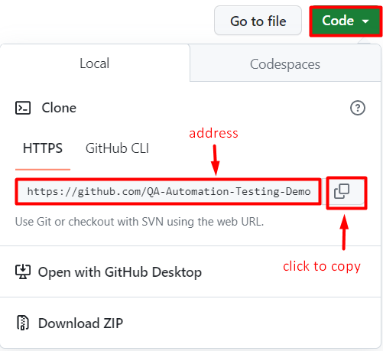

So now that we have our **folder ready** and our **repository ready**, let's clone. Type:

**$ git clone https://github.com/QA-Automation-Testing-Demo/GitDemo.git**

This is how the whole sequence of commands should look like:

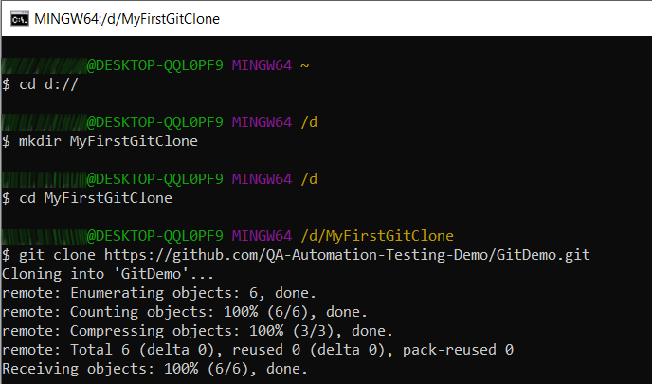

You can check vie Windows Explorer if everything is as it should be.

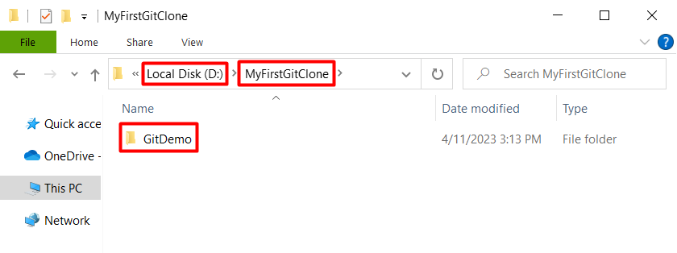

In **GitDemo folder** there should be a file called **GitDemoFile**, which you can open with Notepad. 😉